Obstacles and barriers to the participation of non-state and subnational actors in climate change actions

Introduction

Despite the substantial and ever-increasing volume of successfully implemented climate change actions and initiatives by non-state and subnational actors, and the evidence that this sector has a significant and highly effective role to play in the global battle against climate change, there remain a number of important barriers preventing or hindering this movement.

This note aims to provide a clear outline of the main obstacles and barriers encountered by non-state and subnational actors attempting to participate in actions to combat climate change. It draws from issues repeatedly identified during the last two years of work in this area by ICGC partners including partnership events, surveys, opinions, reports etc.

A non-state and subnational actor (NSA) is an actor that is not a party to the United Nations Framework Convention on Climate Change.

- Access to finance

This is the most obvious barrier and the most frequently cited by all categories of NSA. Based on almost 100 responses to a perceptions survey of needs and challenges, carried out for the purpose of the recent study, lack of access to finance represents a barrier for almost 2/3 of NSAs.
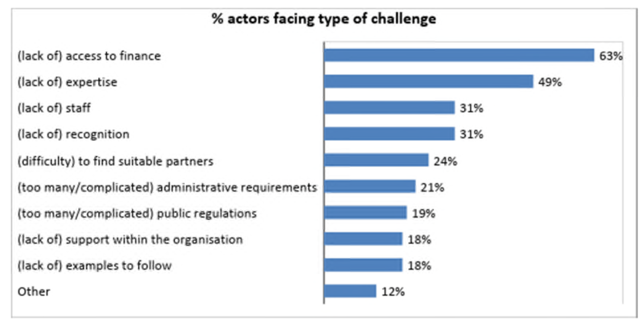
There is no lack of current and future funding available and earmarked for climate actions, but access to these funds proves problematic for a number of reasons.

Lack of information about funding opportunities
There is no clear map of funding opportunities at the non-state and subnational level. Attempts are in progress to map available EU funds and their destinations, but the structure and criteria for allocation of funding is often unclear, and appears to reach only large coalitions, and projects with significant budgets. There is a certain access for the higher tiers of NSAs such as cities and regions, but below this there is neither direct access through a dedicated fund, nor a trickle-down mechanism for the benefit of smaller-scale NSAs.

Inadequate requirements and complexity
These smaller NSAs and projects encounter multiple financing access issues due to lack of knowledge, resources and dedicated funds for their profile. They report disproportionate levels of complexity in the application process and in subsequent reporting requirements, neither of which are adapted to the needs and resources of simpler actions seeking a comparatively small amount of funding. Similarly, where funding is potentially available, the eligibility criteria are invariably either too vague, or too specific and therefore too easily exclude a large number of projects.

Lack of mechanisms to direct private investment flows
Regarding eligibility criteria, there is also difficulty in defining what constitutes a 'green investment'. This can present difficulties for NSAs at all levels. Establishing common indicators or objective criteria for green investors is extremely complicated. Investors are primarily concerned with risk and return, and it is difficult for them to assess the potential impact on the climate of a proposed project, and to measure its chances of success. Private lenders will be reluctant to finance a project without guarantees.

- Legislative framework

Prohibitive regulations
EU legislation and national legislation can often even be prohibitive or counterproductive. The decision-making process is too centralised, and the resulting legislation does not cater for local and regional specificities, or provide for a sufficiently localised operating framework. A pertinent example is that of the disproportionate charges often encountered by NSAs participating in self-generation of renewable energy at a local and community level. Actors in other fields experience specific regulatory barriers that only apply to their particular context, such as construction or food regulations, or regulations imposing a certain organisational structure or legal status. Compliance with these rules would be cost-prohibitive for smaller entities.

Complex regulatory requirements
As mentioned in 1. above, the complexity of reporting requirements is unnecessarily punitive for smaller NSAs proposing simple low-budget projects. These structures are unlikely to have the financial or human resources or the expertise to fulfil such requirements. In the case of public NSAs, EU regulations on state aid and accounting can be strict and similarly prohibitive.

Lack of participatory approaches to the decision-making processes
EU consultation mechanisms on climate action policy and legislation are not sufficiently participatory, through inadequate communication with the public and visibility of the process, and therefore lack public input and transparency.

- Systemic support at EU and national level

Short-termism
The political agenda on national level with respect to climate change is often short-term, and strategies may only be deployed for the duration of the mandate in which they are agreed. There is consequently no long-term vision or continuity.

Lack of recognition
There is currently no clear overview of existing non-state and subnational action in Europe, or potential areas of involvement for NSAs. As the number of climate change actions at these levels continues to grow, there is a need to recognise a corresponding growth in diversity amongst NSAs and their actions, and to tailor the policy framework accordingly.

Disconnect between governance levels
There is no real integration into policy at a national or supranational level of the bottom-up approach or the concept "think global, act local". NSAs lack visibility at the decision-making level, and while the significance of their role is gaining increasing public acknowledgment, it has yet to be properly taken into account in EU and national climate strategy.

Discouraging discourse
There is also a perceived lack of positive discourse with respect to climate action, which can tend to focus on the potential sacrifices and losses of stakeholders, rather than emphasising the positive aspects and potential gains. This may lead to a consequent loss of motivation from NSAs to commit their own resources and time, if they feel there is no realistic chance of their actions having a positive and tangible impact.

- Dialogue and co-ordination

Lack of coordination
As evidenced by the first three points, there is a clear lack of communication and coordination between NSAs of all categories, national and European authorities, and a consequent absence of discussion and consensus on shared goals. Databases are not connected and consolidated, and climate data at national and international level therefore does not necessarily include local data.

Lack of mechanisms for building partnerships
This absence of dialogue and coalition leads to difficulties in finding suitable partners to support non-state and subnational action. There is extraordinary potential for mutually beneficial partnerships but there is no mechanism for identifying and connecting them.

Disconnect with policy development
An absence of dialogue also prevents NSAs from effectively participating in policy development, which is necessary in order to integrate a suitable and appropriate support framework for non-state and subnational climate action, as demonstrated by the European Energy Dialogue for example.

- Internal organisation and resources

Lack of resources
Especially in the private sector, there is frequently a general lack of resources dedicated to climate change action. There are often no employees specifically dedicated to the area, a corresponding lack of training and expertise, and an absence of managerial support to implement such initiatives. Community actions are almost entirely implemented by a voluntary workforce with limited time and access to expert knowledge.

Lack of information
There is a general lack of information available to NSAs on how to become involved in climate actions, and not enough access to case studies and examples for them to emulate. Particularly at the local network and community level, there is a need for easily accessible and concrete information about climate change and actions that can be taken.

Bibliography

NAT/684: Coalition to deliver commitments of the Paris Agreement (EESC, July 14, 2016)

NAT/718: Boosting climate actions by non-state actors (EESC, February 15, 2018)

ENVE-VI/024: Climate finance: an essential tool for the implementation of the Paris Agreement (CoR, October 10, 2017)

European Dialogue on Non-State Climate Action event, report and conclusions (April 23, 2018)

Financing climate action: opportunities and challenges for local and regional authorities (CoR, September 14, 2017)

Toolbox for multi-stakeholder climate partnerships: A policy framework to stimulate bottom-up climate actions (Chan & Bencini for EESC, June 2018)

A community-led transition in Europe: Local action towards a sustainable, resilient, low-carbon future (Ecolise, 2017)

Local, community-led: a new future unfolding (Ecolise, 2018)

Toolbox for multi-stakeholder climate partnerships: A policy framework to stimulate bottom-up climate actions (Chan & Bencini for EESC, June 2018)

